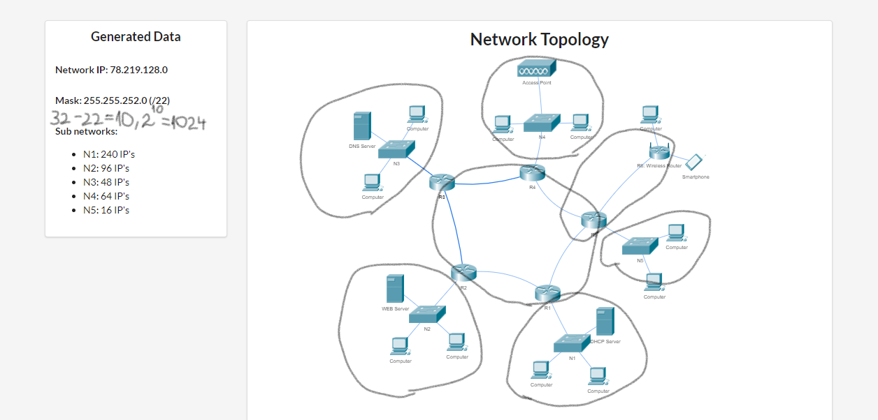

**Network split folosind un binary tree**

1024 /22

512 512 /23

256 256 256 256 /24

128 128 128 128 128 128 /25

64 64 64 64 64 64 64 64 /26

32 32 32 32 32 32 32 32 32 32 32 32 32 32 /27

16 16 /28

8 8 /29

4 4 /30

/22 => 1024 Maximum IP Adresses

N1: 240+3=243< 256=2^8, 8 zeros, 32-8=24 /24

N2: 96+3=99<128=2^7, 7 zeros, 32-7=25 /25

N3: 48+3=51<64=2^6, 6 zeros, 32-6=26 /26

N4:64+3=77<128=2^7, 7 zeros, 32-7=25 /25

N5:16+3=19<32=2^5, 5 zeros, 32-5=27 /27

N12345: 5+2=7<8=2^3, 3 zeros, 32-3=29 /29

N5W:2+2=4 <4=2^2, 2 zeros, 32-2=30 /30

256+128+64+128+32+8+4=620<1024 se incadreaza

Mai avem nevoie de urmatoarele networks:

N12345 : 5 IP’s

N5W: 2 IP’s

**Network split cu intervale**

##### **78.219.128.0 /22**

##### **[0......................................................................................................................................................1023]**

##### **[0.........................................................511][512...............................................................................1023]**

256

##### **[0.................255][256.........................511][512....................767][768............................................1023] network1**

128

##### **[0.................255][256.........................511][512...639][640...767][768............................................1023] network2**

128

##### **[0.................255][256.........................511][512...639][640...767][768..............895][896................1023]network3**

64

##### **[0.................255][256.........................511][512...639][640...767][768..831][832....895][896.........1023]network4**

**[0.................255][256.........................511][512...639][640...767][768..831][832..863][864....895] [896.........1023]**

**...........................[768..831][832..863][864..871][872.......895] [896......................1023]**

**...........................[768..831][832..863][864..871][872..875][876...895] [896.........1023]**

**Enumerarea networkurilor**

**red**

**Fd**

##### -N1: ****78.219.128.0 /24 R1=.1, S1=.2****

##### ****Mask:255.255.255.0****

##### ****-N2:78.219.129.0 /25 R2=.1 ,S2Web=.2****

##### ****Mask: 255.255.255.128****

##### ****-N3:78.219.129.128/26 R3=.129, S3dns=.130****

##### ****Mask: 255.255.255.192****

##### ****-N4: 78.219.129.192 /25 R4=.193****

##### ****Mask: 255.255.255.128****

##### -N5: 78.219.130.64 /27 R5=.65

##### ****Mask: 255.255.255.224****

##### ****-N12345**** 78.219.130.96/29 ****R1=.97,R2=.98, R3=.99, R4=.100, R5=.101****

##### ****Mask: 255.255.255.248****

##### ****-N5W**** 78.219.130.104/30 R5=.105, Rw=.106

##### ****Mask: 255.255.255.252****